


Trilogy EV300

Quick start guide

for caregivers

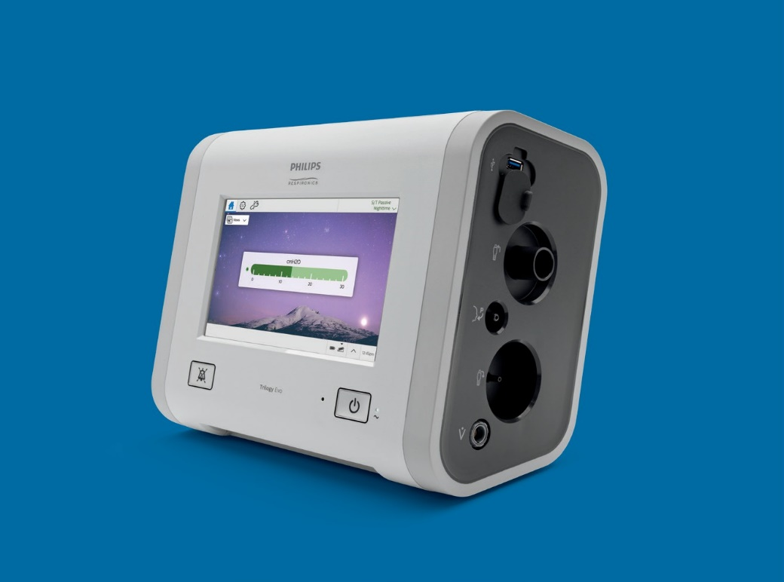

Welcome to your Trilogy Evo ventilator from Philips Respironics. Trilogy Evo is designed for home, on-the-go, and hospital applications, for children and adults, so it can transition with patients through changes in their conditions or their environment.

Trilogy Evo features include:
- Easy to use with a large (8”) touch screen
- Up to 15 hours of power1 for peace-of-mind during extended trips when away from home
- Less than 13 lbs (5.8 kg) including internal and integrated detachable battery, for the perfect blend of weight and power
- Increased durability and improved mobility with in-use carrying case, or wheel chair and roll-stand mounts2

So your ventilator can stay with you wherever you go.

- Run time mode settings for Trilogy Evo: A/C-VC mode ActivePAP circuit, PEEP of 3 cmH2O and Vt 800ml
- Available for purchase

Adjusting to using your new ventilator, Trilogy Evo, will be easy.
- Settings to synchronize with your breathing pattern (inhale and exhale), for a natural and comfortable experience
- Multiple settings for timing, volume, and pressure, so it can be customized for your needs now and in the future
- Available support and training with additional information

This guide provides important information that will help you use the device.
Refer to the caregiver manual for complete details.

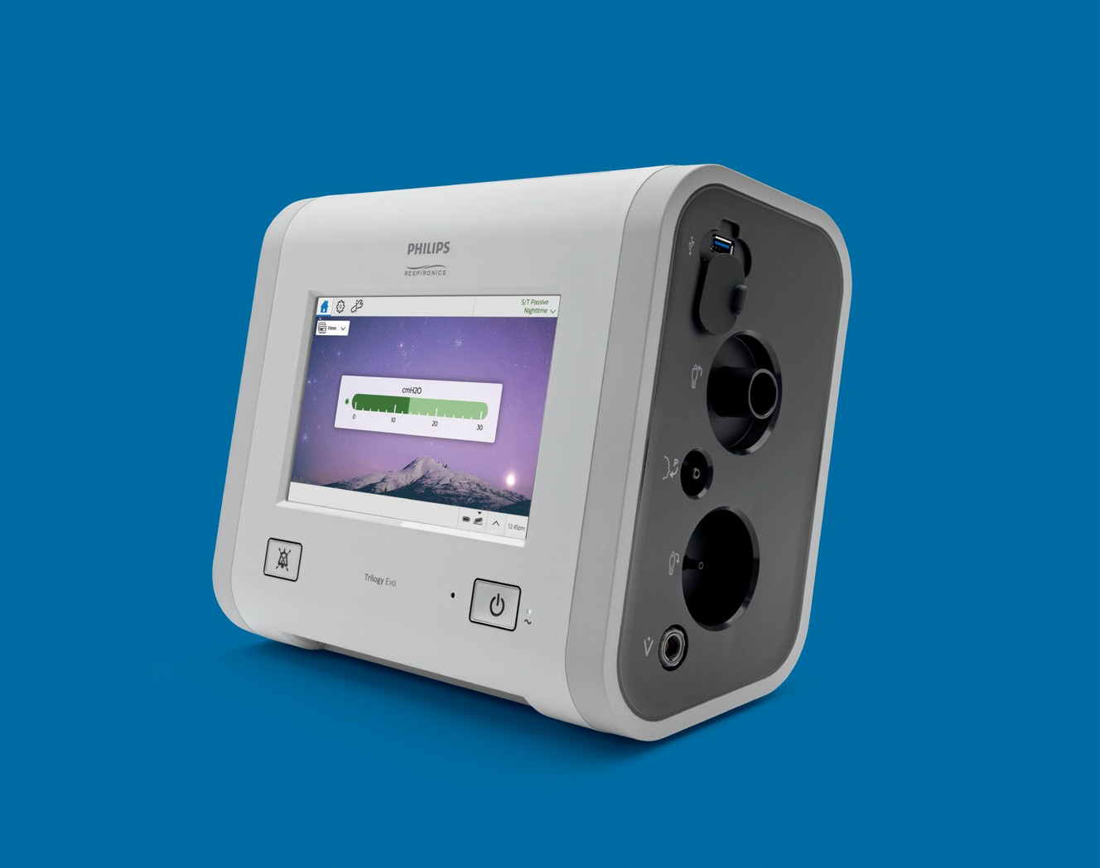

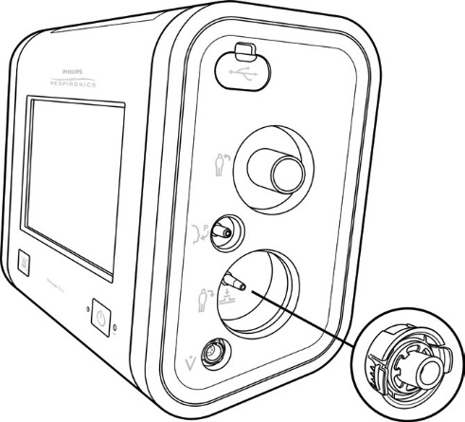
Overview

Light bar

Proximal pressure port

Accessory USB port

Inspiratory port (to patient)

Alarm indicator/ alarm silence
button
Active exhalation valve line connection for Active PAP and Active Flow circuits

On/off (standby) button

Flow sensor cable connector

Dual limb
active exhalation valve connection (from patient)

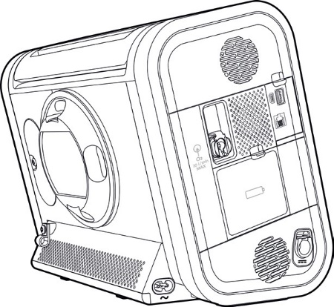
Air inlet foam filter

Low flow oxygen inlet

Accessory USB port

Detachable battery access door

AC power connector
DC power connector

Available circuit options

Passive circuit

Tracheostomy
tube

Exhalation leak valve (exhalation
port)
Mask without integrated leak

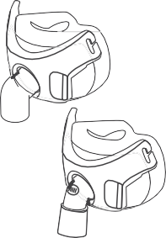
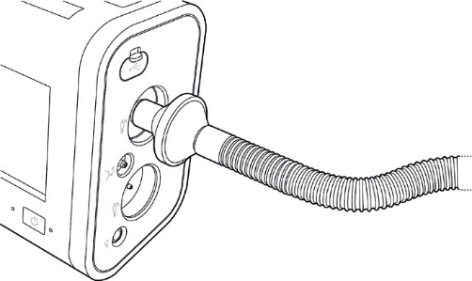





Mask with integrated leak

A

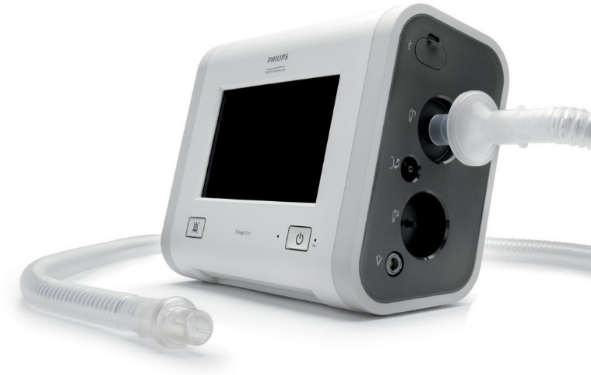

A. Connect the bacteria filter on the circui
to the inspiratory port.
A

Getting started

Prepare for use

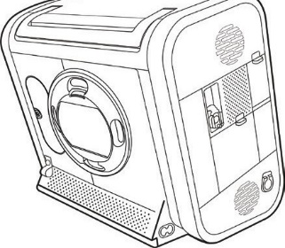
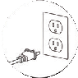
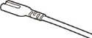
  - Plug in device
Use the AC cord provided to connect
AC power. The green LED light next to the on/off (standby) button should be lit.


If AC power is not available, you can use battery or DC power.

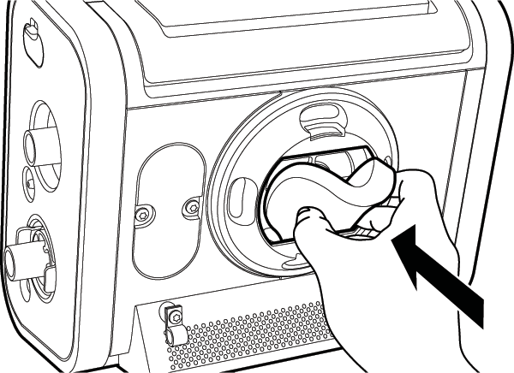
  - Install filter
To install the air-inlet foam filter, pinch the filter as you press it into the filter cover as shown. Position it securely behind the top and bottom restraints.

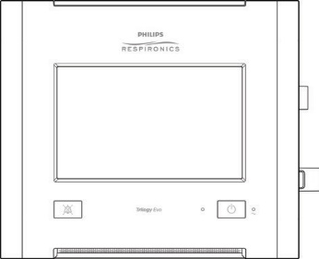
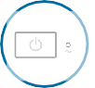
  - Starting Trilogy Evo
Make sure all accessories, cords, and circuit connections are attached. Press the on/off (standby) button.
If starting on battery power, a notification will appear at the top of the screen along with
a beep every 30 seconds. Tap the reset icon beside the notification to acknowledge.

Home standby window*



The home standby window shows after the device is turned on
Standby Not Ventilating

Prescriptions
A/C-PC AVAPS
Passive Daytime
A/C-PC AVAPS
Passive
Nighttime

Start Ventilation
12:45pm

12:45pm

Prescriptions
Your therapy prescriptions will be listed here, for selection
Start Ventilation button

  - Select your prescription

  - Tap Start Ventilation to begin therapy

If you want to stop therapy, press the on/off (standby) button on the front panel, then tap Standby or Power Off.

*Please note that your device’s screens may look different than those pictured here.

Views
Tap Views drop down arrow to access multiple monitoring options
Standby Not Ventilating
Prescription menu Your prescription and circuit in use will be shown here. If your device is not ventilating, this area will read “Standby Not Ventilating”






0 10 20 30

12:45pm

12:45pm
cmH2O
A/C-PC AVAPS Passive
Daytime

Views

Breath indicator When the current breath is triggered by the patient, this indicator appears filled (dark green)
12:45pm

Manometer This bar will move based on the pressure being delivered
Battery time Estimated remaining battery time, based on prescription in use and breathing pattern

Touchscreen lock To prevent accidental therapy changes, use
Touchscreen Lock. Lock the screen any time with the Status Bar shortcut shown here

Internal 06:36

Detachable 06:48

Prescription settings
12:45pm

Prescriptions settings window

Tap the settings icon to view more details about your prescriptions


Alarm settings Switch tabs to view alarm settings
Tap Circuit, Mode, or Advanced options on the left to see more information

12:45pm
Active Humidification
Off
Size
Adult (19-22mm)
Type
Passive
Using Default Calibration
Circuit

Advanced
Mode
A/C-PC AVAPS
AVAPS Speed
5 cmH2O/min
Insp. Time
1.5 s

Rise Time
2
PC Min/Max PEEP
10/20 cmH2O 5 cmH2O Trigger Type Trigger Sens.
Auto Trak Auto
Tidal Volume
400 mL

Breath Rate
15 BPM
Circuit
Passive

Start Ventilation
Daytime
Standby Not Ventilating

Alarm settings
12:45pm

 |  |  |  |  |  |  | Standby Not Ventilating
Daytime |  |  |  | Start Ventilation
Circuit |  |  | Tidal Volume |  | MinVent | Resp. Rate | Circuit Disconnect
Passive |  |  | Off/Off mL |  | 3.5/Off L/min | Off/45 BPM | 10 s
Mode
A/C-PC AVAPS
Advanced
 |  |  |  |  |  |  |  |  |  | 12:45pm

Prescription settings (continued)

Selecting a different prescription while ventilating



Option
A/C-PC AVAPS PassivStandbe y
NotDaytimeVentilating
Vte
400 mL
PIP
21.1 cmH2O
1.
In the home window, tap the prescription drop-down arrow to access the prescription menu. Then, select a prescription to switch therapy
A/C-PC AVAPS Passive
Daytime
Views
PC Min/Max
10/20 cmH2O
Tidal Volume
400 mL
PEEP
5 cmH2O
Breath Rate
15 BPM
Insp. Time
1.2 s

12:45pm

RR
15 BPM
MinVent
6.0 L/min
30
20
10
0
cmH2O
sive
A/C-PC AVAPS Pas
Nighttime

sive

A/C-PC AVAPS Pas
Daytime


Option 2.
Standby Not Ventilating
12:45pm
From the settings window, tap the drop-down arrow, select your new prescription, and then tap Switch Therapy

A/C-PC AVAPS Passive
Daytime
Daytime

Start Ventilation

A/C-PC AVAPS Passive Daytime
Daytime

A/C-PC AVAPS Passive Nighttime
ume L

te
Mode Breath Ra
A/C-PC AVAPS 15 BPM
Circuit Tidal Vol
Passive 400 m
PC Min/Max
10/20 cmH2O Trigger Type
Auto Trak
PEEP
5 cmH2O Trigger Sens. Auto
Insp. Time
  - s

Rise Time
2

Advanced
AVAPS Speed
5 cmH2O/min

Circuit
Using Default Calibration
Type
Passive
Size
Adult (19-22mm)
Active Humidification
Off

12:45pm

Circuit note: The circuit settings must be the same as the current prescription. If the circuit settings differ, place the device into standby to change the physical circuit. Then, select the prescription from the home screen to start ventilation.
12:45pm

Options

Options window
Tap the options icon for the Options menu window

Device Options
Calibration & Setup
Data Transfer
Alarm & Event Log
Information
Prescription Preferences
Within this window, change device options, run calibrations and tests, and view and work with data

12:45pm
Options
Standby Not Ventilating

Device options
12:45pm

 |  |  |  |  |  |  | Standby Not Ventilating
 | Device Options
Language  English |  |  | Alarm Volume  Low |  | Screen Brightness  3 | Light Bar  Off
Automatic Touchscreen Lock  Off |  |  | Screen Saver  Breath |  | Date and Format  MM/DD/YYYY | Time and Format  12-Hour
Bluetooth
Not Enabled
 |  |  |  |  |  |  |  |  |  | 12:45pm
You are able to tap any of these device options and change if needed, including light bar, touchscreen lock, screen saver, and more
12:45pm

Alarms

Disconnected Circuit example
This is an example of an alarm situation that may occur and how to respond.

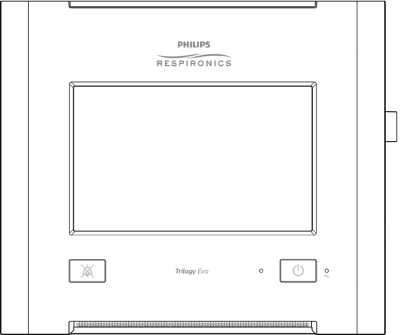


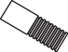
Light bar & alarm silence When a circuit has become
Standby Not Ventilating

cmH2O

0 10 20 30
Views
A/C-PC AVAPS Passive
Daytime

Reset
Circuit Disconnected 1
disconnected, you can see the high priority audio and visual indicators

12:45pm
1:59

Alarm silence button
Visually monitor the patient and ventilator at all times during an alarm silence period. Allowing alarms to continue without intervention may result in harm to the patient. If you want to silence the audible alarm for two minutes, press the Alarm Silence button

Resetting an alarm
Standby Not Ventilating
Circuit Disconnected 1




To clear the alarm message, tap the alarm reset icon
12:45pm
Reconnect the circuit. When the alarm condition resolves, the alarm message will turn gray
Circuit Disconnected 12:45pm

12:45pm
Page 1/1
30
20
10
0
cmH2O
A/C-PC AVAPS Passive
Daytime

Reset

Circuit Disconnected

Views

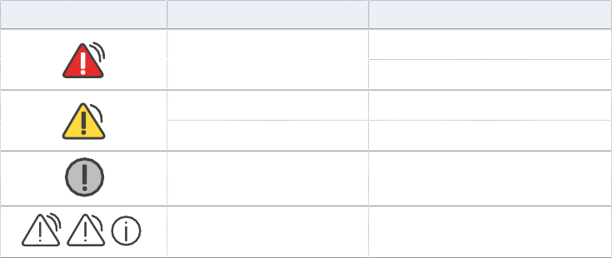
Alarms (continued)

Icon | Description | Light and Sound Indicators
 | High priority alarm | Light bar flashes red
 |  | Audible alarm repeats rapidly
 | Medium priority alarm | Light bar flashes yellow
 | Low priority alarm | Audible alarm repeats moderately
 | System message | Single beep
 | Resolved alarm or system message | None

Alarm name | What happened? | What to do
Ventilator Inoperative | The system self-test indicates a failure or malfunction of a component. The failure causes therapy to stop or not meet essential performance criteria. | Provide an alternate method of ventilation then contact customer service.
Ventilator Service Required | This alarm occurs when the device cannot perform to specification, a backup safety feature is compromised, or the delivery of therapy is compromised. The device continues to function. | Contact customer service.
Obstruction | The ventilator detects an obstruction in the patient’s inhalation path, exhalation path, or external flow sensor. The ventilator detects that the leak device is missing. | - Check the circuit. Is it kinked or pinched?  - Check the bacterial filter. Is it blocked?  - If using an Active Flow or Dual Limb circuit, check the HME. Is it blocked?  - Is the leak device blocked or missing?  - Is the external flow sensor blocked?
Apnea | Time between patient- initiated breaths is more than the alarm setting. | - Is the circuit connected to the patient?  - Is there a leak or disconnect?  - Is the circuit kinked or pinched?
High Expiratory Pressure | During the expiratory phase, the delivered pressure exceeds the target patient pressure by 5cm H2O or more. | - Check the circuit. Is it kinked or pinched?  - Is the leak device blocked or occluded?

Alarm name | What happened? | What to do
High Inspiratory Pressure | During the inspiratory phase, the delivered pressure exceeds the target patient pressure by 5cm H2O or more. | Check the patient:  - Is the patient coughing or having excessive secretions?  - Is the patient having bronchospasms? Is the tracheotomy tube stable?  Check the ventilator:  - Is the circuit kinked or pinched?  - Is the leak device or the exhalation device blocked?  - Are secretions in the HME?
Active Exhalation Valve Failed | The active exhalation valve is stuck closed. | - Single-limb active circuit: check all connections to the valve and check that the valve is clear.  - Dual limb circuit: check that the valve is clear.  - Replace the circuit or valve if necessary.
Check AEV Pilot Line | The active-exhalation pressure control line is not connected, becomes disconnected, or contains water droplets that affect the active exhalation valve line pressure reading. | Inspect the line. Empty or replace it if necessary.
Proximal Pressure Line Disconnected | The proximal pressure line is not connected. | - Is the line connected at both ends?  - Is the line clean and not tangled?  - Be sure the main circuit is connected and does not have large leaks  - Be sure the exhalation valve is intact.
Circuit Disconnected (MPV) | When using mouthpiece ventilation, the system detects the circuit is disconnected. | Reconnect the circuit.
Circuit Disconnected | The patient is not connected to the ventilator breathing circuit or there is a large leak. | - Is the circuit connected to the patient?  - Is the circuit connected to the ventilator?  - Does a large unplanned leak exist?
Low Minute Ventilation | The patient’s minute ventilation is less than or equal to the alarm setting. Or, no breath has occurred for 15 seconds. | - Is the circuit kinked or pinched?  - Does the circuit have a leak or disconnect?  - Remove excessive water from the tubing.  - Is the bacterial filter blocked or not connected?  - Is the leak device blocked or not connected?  - Check the patient

Alarms (continued)

Alarm name | What happened? | What to do
Low Respiratory Rate | The patient’s respiratory rate is less than or equal to the low respiratory rate alarm setting. Or, no breath has occurred for 15 seconds. | - Is the circuit kinked or pinched?  - Does the circuit have a leak?  - Is the circuit connected?  - Check the patient.
High Inspiratory Pressure | Applies to volume modes.  The measured patient pressure exceeds the High Inspiratory Pressure setting. | Check the patient:  - Is the patient coughing or has excessive secretions?  - Is the patient having bronchospasms? Is the tracheotomy tube stable?  Check the ventilator:  - Is the circuit kinked or pinched?  - Is the leak device or the exhalation device blocked?  - Are secretions in the HME?
No Trigger | Applies to mouthpiece ventilation. The time between patient-triggered breaths is greater than the No Trigger alarm setting. | - Check the patient  - Is the circuit within reach?  - Is the circuit intact?  - Is the PEEP high enough to generate sufficient signal flow when the mouthpiece is touched?

USB data
If your homecare provider or clinician asks you to download your ventilator data to USB in order to review your therapy, carefully follow the next steps:

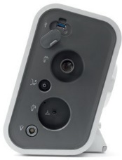
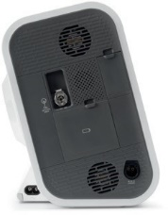
- Connect the USB drive into any
of the 2 USB connectors on either sides of the device.
- In the menu bar, tap the options icon and then tap Data Transfer.
- Tap Export Data–USB to start the transfer to the USB drive.
- Tap USB in the pop-up to confirm the destination for the export.
- Tap Yes in the pop-up to confirm export ventilator data to USB.
- Wait for Export Data-USB to display
Success before removing USB stick.

Device maintenance*

Cleaning the device


Frequency
Clean Trilogy Evo’s exterior surface weekly
Supplies
- 1 lint-free cloth
- 1 soft-bristle brush
- Liquid dishwashing detergent solution:
1 teaspoon of liquid dishwashing detergent per gallon of warm water

Instructions


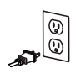
- To clean the exterior, first turn the device off and disconnect it from the power source detaching all accessories and connectors.


- Use a dampened lint-free cloth (not dripping) with detergent solution to clean the exterior of the enclosure.

- Use a soft-bristle brush in the areas around the screen, buttons, and any other areas where soil may be difficult to remove. Ensure you remove all visible soil.
- Use a dampened lint-free cloth (not dripping) with clear water to remove all detergent residue.



- Use a dry lint-free cloth to dry the enclosure.

- Inspect the device for cleanliness and repeat the cleaning steps until the surfaces are visibly clean.


- Inspect the device for damage after cleaning.
If any parts are damaged, contact customer service.

*For accessories cleaning/disinfection instructions vary based on the type of accessories you use. Please refer to your IFU for how to clean/dispose of your circuits.

Cleaning the battery

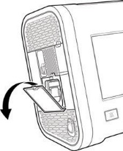
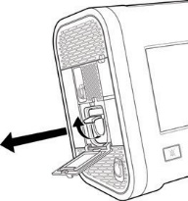
  - Open the detachable battery access door.
1
2

  - Lift the battery handle and pull it to remove it from the bay and follow the instructions for cleaning the device (pg. 22).

  - Allow the battery to air dry completely and then inspect it for damage after cleaning.

  - Slide the battery back into the bay until you hear a click.

Rinsing the air-inlet foam filter
The air-inlet foam filter is the gray foam located on the back panel. It protects Trilogy Evo from dirt and dust. This filter is for single patient use. Only use Philips Respironics- supplied filters. Ventilation can continue while you are replacing the filter.
Frequency
Rinse monthly and replace every six months.

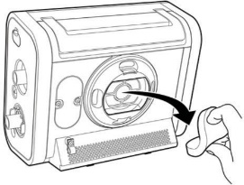

Instructions
1
- Ensure you have a replacement filter nearby.

- Pinch the filter and pull it out of the filter cover.

- Insert the clean replacement filter into the filter cover. Ensure it is positioned securely.

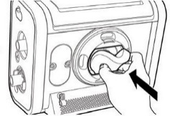

- Visually inspect the filter you just removed from the device — if it is damaged, discard it. Otherwise, rinse the dirty filter in clear water. Inspect the filter for cleanliness and repeat until the filter is clean.
2

- Allow the filter to air dry completely before reinstalling it.

Contacts

*NOT FOR EMERGENCES*
If you are concerned for your child’s health and/or safety please seek medical advice or call 9-1-1

Contact | Phone/email | Hours
Home Trach & Vent Secretary | 604-875-2729 | Monday to Friday  7:45 – 3:45 | For making appointments or if you need to speak to a team member
Home Trach & Vent Clinic Voicemail | 604-875-3955 | Monday to Friday  7:45 – 3:45 | Please leave a message if you have questions regarding your equipment. A Respiratory Therapist will contact you within 2 business days
Home Trach & Vent Clinic Email | HTVclinic@cw.bc.ca | Monday to Friday  7:45 – 3:45 | Please leave an email if you have questions regarding your equipment. A Respiratory Therapist will contact you within 2 business days

Vendors
Once your child’s own equipment comes in, one of these companies will provide all equipment going forward

West Care Medical | 1-604-540-8288
Vital Aire | 1-800-637-0202
MedPro Respiratory Care | 1-800-310-1444

Please contact for any concerns about your medical equipment

If your equipment FALLS or is DAMAGED, DO NOT PLUG it in or turn it on until it has been checked by a technician.

At Home Program Product Distribution Center

Hours of operation | Monday to Friday 8 am to 4:30 pm  Closed all weekends and stat holidays
Phone number | 604-927-2910
E-mail | Pdc.callcenter@gov.bc.ca

To Place an Order (by phone or e-mail)

- State that you are placing an order for a child registered on the At Home Program.
- Provide spelling of child’s last name, first name and date of birth.
- Provide phone number and delivery address.
- Itemize each product and required quantity.
- Confirm the date and time of delivery.
*It will usually take 3 business days for the order to be received*

Receiving the Order

- Have someone at your home to receive the order at the day and time that has been arranged.
- Check the contents of the boxes to ensure the correct supplies have been sent.
- Contact Product Distribution Center for discrepancies.

Include list of re-orderable supplies

Notes

