
ResMed AirCurve

Non-Invasive Support Package

- DISCLAIMER -

This education package is designed to be a learning supplement for families and caregivers being taught by healthcare professionals. This package does not aim to comprehensively cover every aspect of what families and caregivers should know about this device and the therapy it offers. Every patient and situation is unique and may require modification of the contents of this package. As such, this document should not override the recommendations of healthcare professionals.
This package is not intended as a replacement for product manuals, but rather as an education tool that offers families and caregivers a resource of organized and easy-to-follow information about the set-up and use of their child’s healthcare equipment. As always, additional information can be found in the product manuals provided by the manufacturers.


Updated on July 28, 2021

Non-Invasive Support

What is Non-Invasive Support?
When breathing becomes difficult for a person, big or small, we have tools to help. Non-invasive support, in both the hospital and the home, is a way we can help people breathe that uses a mask to give pressure to their lungs and airway. Depending on what your child needs, this pressure can be used to assist breathing with pressure changes (BiPAP), or just to keep lungs and airways more open with a single pressure (CPAP).

Why do we use the ResMed AirCurve?
The Curve machine is a simple, small, and versatile portable non-invasive ventilator. It is lightweight, durable, and can support a wide range of patient sizes from adults to infants (>13 kg). It provides support through a singular piece of tubing called a “single-limb circuit” that pushes air and oxygen to a mask and allows exhaled air to escape through tiny “leak ports” in the mask.

Most importantly, it can offer a full suite of support modes that can fulfill any non-invasive need.

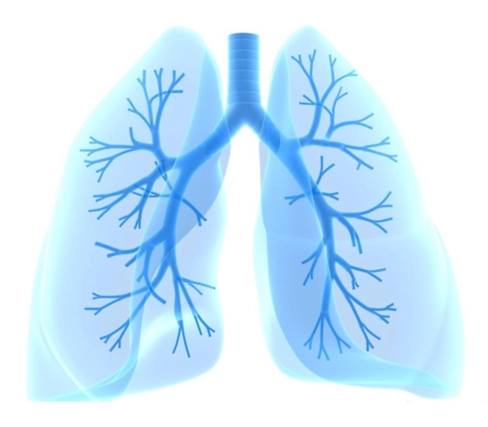

Why does your child need Non-Invasive Support?

This is a very important question to ask yourself if you have a loved one that requires home respiratory support. There are a lot of reasons why an infant or child might need to wear a CPAP or BiPAP mask for assisted breathing. Often CPAP and BiPAP are needed to assist with upper airway obstruction, but most things that make breathing more difficult can be improved with non-invasive support. Examples might include anything from heart or lung disease to a variety of neurological and neuromuscular conditions. Use of non-invasive respiratory support may be temporary, or life-long. In some cases, it may be necessary to wear the mask 24 hours a day, but in most cases, use is primarily during sleep (“Nights and Naps”). It is very important for families and caregivers to understand the reasons for these things so that they can respond well to the needs of their child.

Modes of Support

What is a ventilator mode?
Ventilators have many ways they can offer pressure to support breathing, and each different way is called a “mode.” There are three types of breaths a mode may give, and the way a mode uses these breath types will decide when and how pressure is delivered to the patient.

What types of breaths can modes give?
Spontaneous Breath: The patient has full control. Breaths are started and ended by the patient.

Assisted Breath: These breaths are started by the patient, but last for a set time before allowing exhalation. This gives the ventilator more control over how the breath goes in, while allowing the patient to decide when the breath starts.
“PAC” Mode
(Pressure Assist Control)

This mode uses a mix of Assisted and Mandatory Breaths where the ventilator always has control over how the breath is given, and makes sure the patient breathes at, or above, a minimum respiratory rate. The inspiratory pressure is given over the entire set inspiratory time, regardless of whether the breath is assisted or mandatory.
Mandatory Breath: The ventilator has full control. Breaths are started and ended by the ventilator.
“CPAP” Mode
(Continuous Positive Airway Pressure)

This mode does not give any breaths, but instead makes breathing easier by giving a single consistent pressure that acts to keep the lungs and airway open. All breaths are controlled by the patient completely without the assistance of the ventilator. If the patient stops breathing for any reason, a back-up mode like “PC” Mode can be set to take over after a period of time.
“S” Mode
(Spontaneous)

In this mode, all breaths are spontaneous breaths, and the patient has full control. A set amount of inspiratory pressure (called “IPAP”) is given when the patient begins a breath, and a set expiratory pressure (called “EPAP”) is given when the patient finishes breathing in and begins to exhale.
“S/T” Mode
(Spontaneous Timed)

This is similar to S Mode, but a respiratory rate is set. If the patient does not breathe within a set time frame, a Mandatory Breath is given. This ensures that if a patient slows down too much, or forgets to breathe, they still get a breath from the ventilator. Both Spontaneous and Mandatory Breaths give the same amount of inspiratory pressure.

What are some modes the Bipap has?

Modes of Ventilation

“CPAP” Mode

“S” Mode OR “S/T” Mode
(When breathing OVER the set RR)

“PAC” Mode OR “S/T” Mode
(When breathing UNDER the set RR)

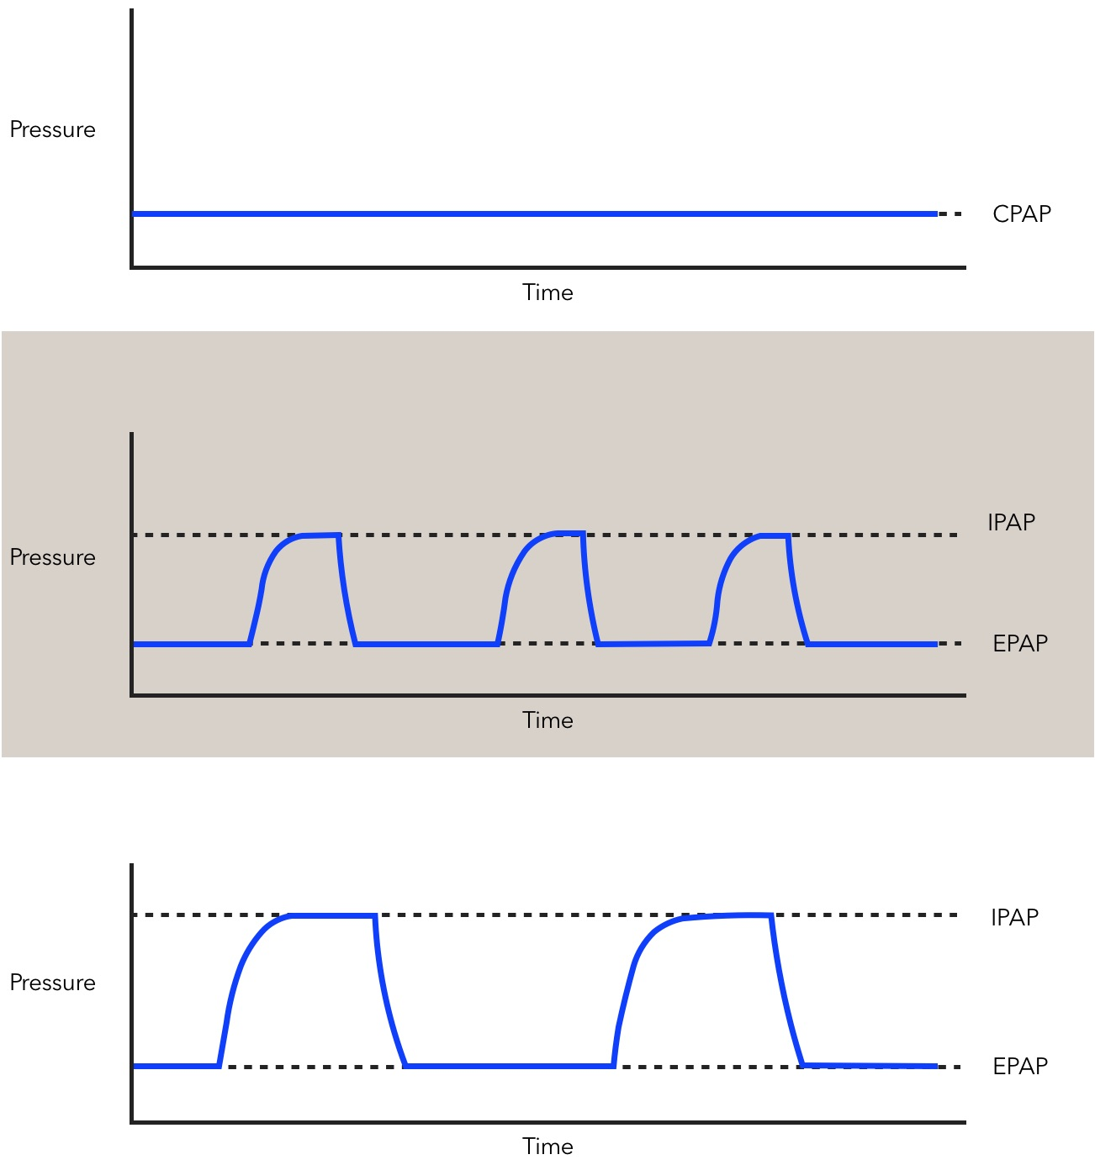

Home Setup

What are my child’s ventilator settings?
Support
Mode: _____________
Circuit: Passive
Mask: ________ Head Gear: _______
Oxygen Flow: __________L/min
IPAP: ____________cmH2O
EPAP / CPAP: ____________cmH2O
Pressure Min / Max: /. cm H20
Breath Rate: ___________/min
Inspiratory Time: ___________sec
Ti Min/ Max: ______/_______
Rise Time: ________________
Easy Breath: _____________
Trigger/ Sensitivity: ________________
Cycle Sensitivity: _______________
Ramp Time / Length: ___________min
Ramp Start Pressure: ______cmH2O
System One Resistance: __________
Tubing Type: ______mm

Measured Values
Leak: _________L/Min
Minute Ventilation: ___________ L/Min
Tidal Volume: _____________ mL
Respiratory Rate: ___________bpm

Alarms
Circuit Disconnect: __________sec
Low Minute Ventilation: ________________ L/min Apnea Alarm: _____________sec
High Respiratory Rate: ________________/min
Low Vte: ____________ml
Low Minute Ventilation: ________________L/min

Humidification
System One Humidification: ON / OFF
Climate Control: _____________
Humidifier Level: ________
Heated Tube: YES / NO
Tube Temperature: ______
Humidity Level: ________

To access the Clinical Menu:
• Press and hold the DIAL and the HOME button for three seconds.
The Home screen is displayed with an unlock icon in the top right corner of the screen.
To exit the Clinical Menu:
• Press and hold the dial and the Home button for three seconds.
• Select Exit Clinical Menu from the Home screen.
The device will automatically exit the Clinical Menu after 20 minutes of inactivity.
Dial

Machine Components
Home

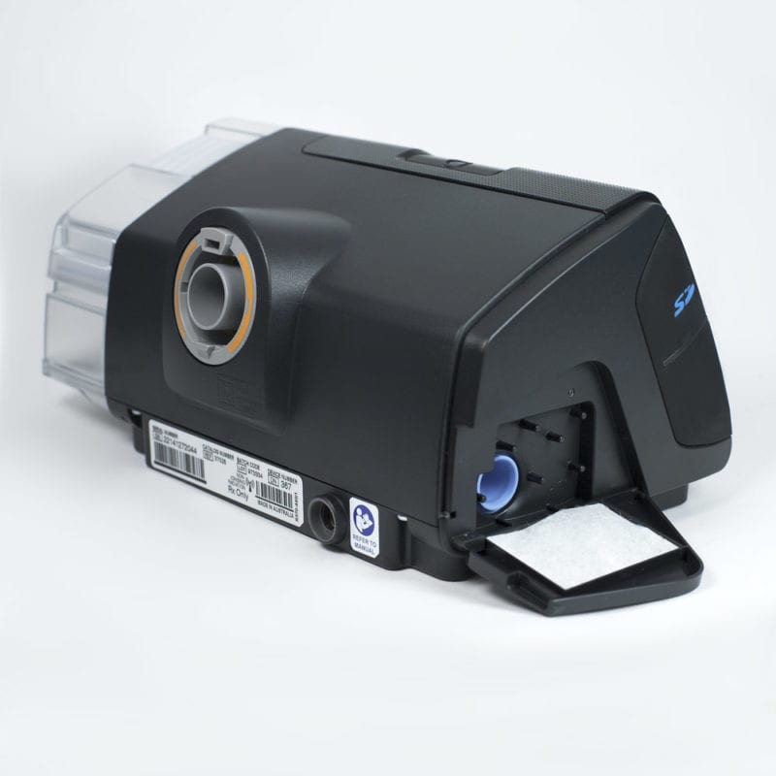
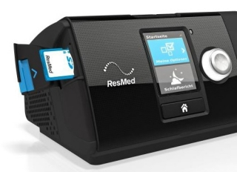
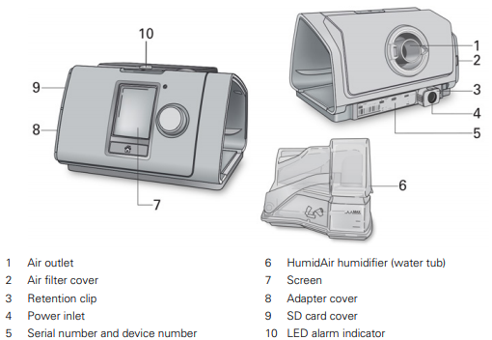
Filter
SD Card

Screen Navigation

How do I navigate the screens on the Bipap?

A screen that provides simple graphics and measured values and can display additional detailed ventilator information when needed.
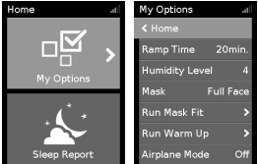

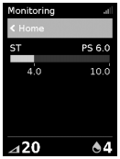
This screen can be accessed under the monitoring option. In order to view set parameters you will need to access the clinical menu. This is done by holding down the Dial and home button simultaneously.

What can I do in the Menu?

My Options: Change humidity level, Run warm up.

Alarm Log: View all past alarms and notifications.

Circuit Setup – Heated Circuit

A

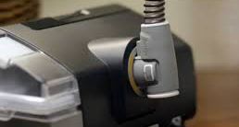
What do I need to build a Heated Circuit?
To start building the circuit, collect:
- ResMed Curve Ventilator
- Detachable Humidifier Module
- Flexible Heated Tubing
- AC/DC Power Adapter
- Power Cord
- White Filter
Heated tubing attached to the back of the ResMed Sense

- Carrying Bag

Carrying bag

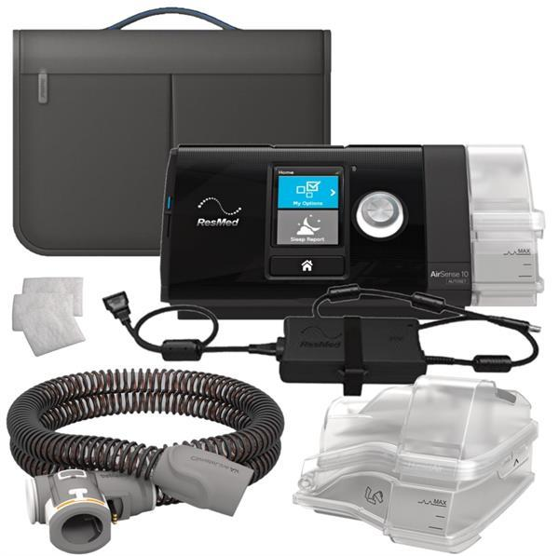
ResMed Curve Ventilator

White filters
Power cord with AC/DC Power Adapter

Humidifier Chamber
Flexible Heated Tubing

A

Circuit Setup - Non Heated Circuit

B
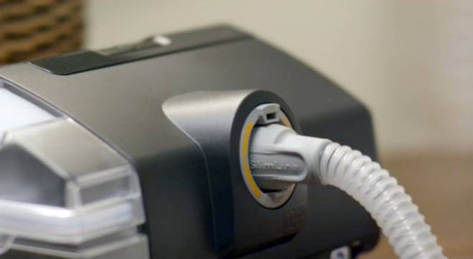
What do I need to build a Non Heated Circuit?
To start building the circuit, collect:
- ResMed Curve Ventilator
- Detachable Humidifier Module - EMPTY
- Flexible Non Heated Tubing
- AC/DC Power Adapter
- Power Cord
- White Filter
Non Heated tubing attached to the back of the ResMed Curve
- Carrying Bag
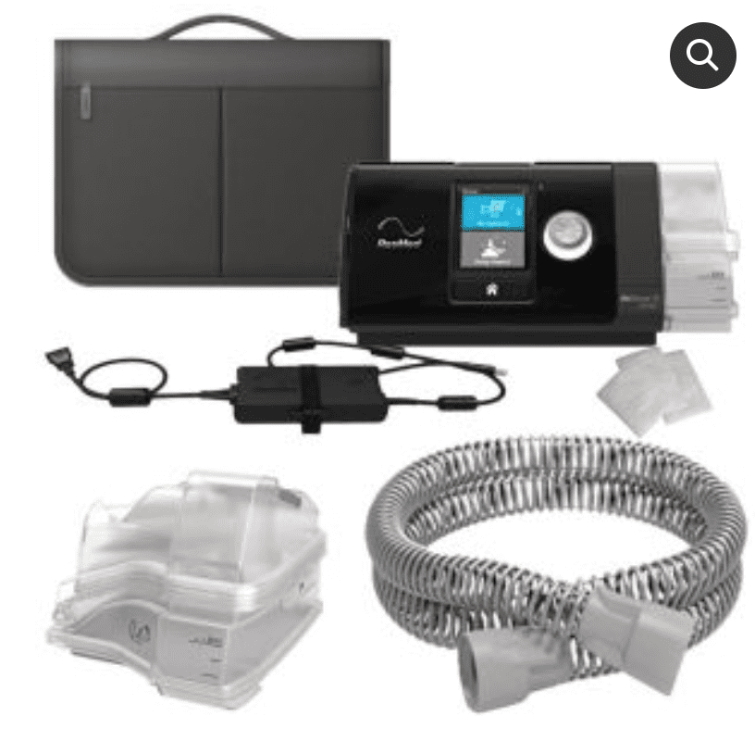
Carrying bag
ResMed Curve Ventilator

Humidification
Non Heated Tubing
White filters
Humidifier Chamber
Power cord with AC/DC Power Adapter

Why is heated humidification important?
Breathing cool, dry air can irritate a person’s airways and thicken secretions making it hard for them to breathe. The nose and throat act to warm and moisten inhaled air as it travels down to the lungs. Respiratory gases generated through the Bipap machine would be delivered at room temperature (about 21 °C). Long term exposure can lead to irritated airways and thick secretions. Heating and humidifying the air increases comfort.
How does it work?
The Humidifier System adds heat and water to the air moving through the breathing circuit. It does this by heating water and allowing the air to pass over the water on its way to the patient.

The Humidifier Pot holds the water. The Humidifier Base heats the pot enough to make the air passing through about 36°C. The air leaving the humidifier is now humidified.

The Humidity Level can be set to Off or between 1 and 8, where 1 is the lowest humidity setting and 8 is the highest humidity setting.

Prior to placing on a patient, you should always check and ensure that the humidifier is filled with sterile/distilled water.

What circuit parts are involved in humidification?
The ResMed humidification system has two parts: A Humidifier and water Chamber, and Patient Tubing (Heated).
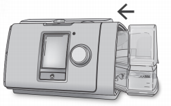

What is the Climate Control function?
Climate Control is an intelligent system that controls the humidifier and the ClimateLineAir heated air tubing to deliver constant, comfortable temperature and humidity levels during therapy.
In the main menu is an option to ‘Run Warmup’. This function when selected will pre-heat the humidifier and tubing prior to use making for a more comfortable initiation of therapy.

Heated Tube Humidification

What does the heated tube do?
Air holds more water when it is hot, so if it is allowed to cool on its way to the patient, water will rain out and fill up the low parts of the circuit. This is one of the reasons why we use Heated Tubing, which heats the tube and keeps the air warm enough that it will not lose any of its original heat and water.
What is tube temperature?

A heated tube helps keep the air warm, so that it does not cool down before it reaches your child. When using a heated tube. The Tube Temperature can be set to anywhere between 60–86°F (16–30°C), or turned off completely. The temperature sensor located at the mask end of the ClimateLineAir heated air tubing enables the system to automatically control the temperature of the air delivered to the patient. This ensures the temperature of the air delivered to the patient does not fall below the set minimum temperature, therefore maximizing breathing comfort for the patient.

How do I refill my humidifier?
The removable water chamber allows the chamber to be removed and refilled. It is important to ensure that the humidifier chamber is filled when the machine is in use.
Note: Do not pull the chamber lid open more than 90 ° as it can break.

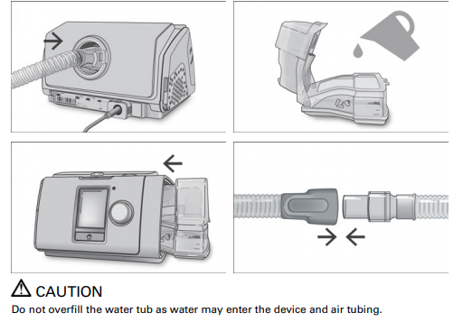
Cleaning Considerations
Always allow the humidifier chamber to cool down completely before removing to clean. Failure to do so may cause burns.
Empty water out of the humidifier chamber every morning, to prevent mold and when washing the humidifier be sure to take the seal out and clean it also.
1. Remove the water tub from the device, open it and discard any remaining water.
2. Hold the water tub base and then fully open the water tub lid and pull it away so that it easily
detaches from the base.
3. Remove the water tub seal from the water tub lid by pulling it away.
To insert the water tub seal after cleaning it:
3
3

- Place the seal into the lid.
- Press down along all edges of the seal until it is firmly in place.
- Insert one side of the lid into the pivot hole of the base. Slide the other side down the ridge until it clicks into place.
To replace the air filter
- Open the air filter cover and remove the old air filter. The air filter is not washable or reusable.

- Place a new air filter onto the air filter cover and then close it.

Make sure the air filter is fitted at all times to prevent water and dust from entering the device.
Travelling

Patients can take their ResMed device wherever they go.

Advise patients of the following:

  - Use the travel bag provided to prevent damage to the device.

  - Empty the water tub and pack it separately in the travel bag.
  - Make sure the patient has the appropriate power cord for the region of travel.

  - When using an external battery, turn off the humidifier to maximize battery life. Do this by turning the Humidity Level to Off.

  - When on the plane turn Airplane Mode ON and ensure when you are home that you turn Airplane Mode OFF.

Leak
The machine is leak compensated. This means the machine will compensate for the mask leak. Therefore the ideal leak is 0-5LPM. This will now be the leak from the mask not fitting well.

Battery
There is NO INTERNAL BATTERY. Therefore a separate battery pack will need to be connected if the power is lost. Further in this handout a battery pack will be explained. The battery pack MUST be plugged in and fully charged as part of the emergency preparedness plan.

Supplemental Oxygen

How is oxygen given on the Curve?
The device is designed to be compatible with supplemental oxygen of up to 15 L/min. To connect supplemental oxygen to the device you can either connect a Climate Line Air Oxy or an oxygen connector port.

Actual delivered oxygen percentage is affected by the pattern of breathing and amount of leak. High leak and fast breathing will decrease the percentage of oxygen that is given to the patient.

When turning off the ResMed Device, ensure the 02 flow is turned off first. This is to prevent oxygen accumulation in the device and decrease risk of fire.

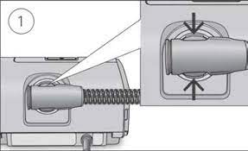
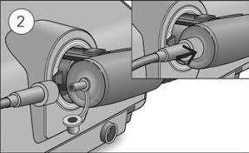

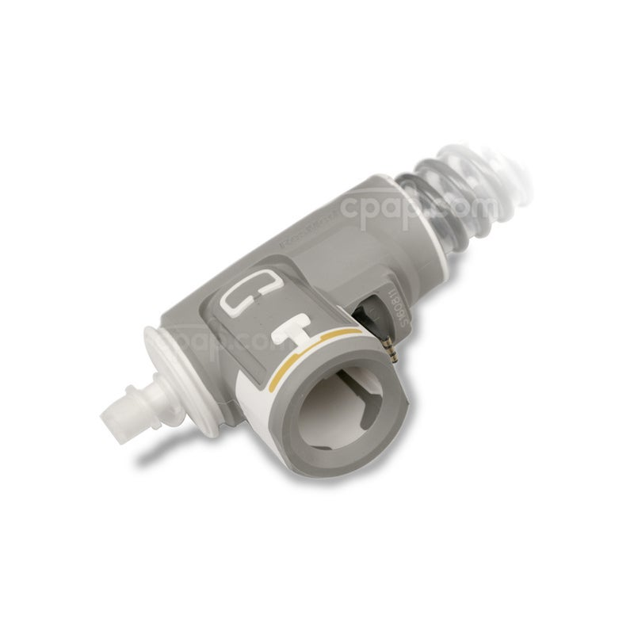
- Remove the cap from the oxygen connector.
- Connect the oxygen supply tubing to the oxygen connector.
Make sure it is firmly attached.
Equipment Cleaning
Schedule for Cleaning and Disposal of ResMed Equipment
How do I prepare to clean my equipment?
Always prepare fresh solution for each cleaning cycle and discard solution after each use, to prevent the possible risk of infection from contaminated cleaning/disinfection solutions. It is recommended to designate bins that will be used for cleaning only equipment. One bin can be used to wash/disinfect, while the other bin can be used to rinse. Use a towel to air dry equipment. Please refer to bottom of page for recommended cleaning schedule.
- Shut off unit using power switch and disconnect from power source.
- Thoroughly wipe the inside of the heated breathing tube connection port and outside surfaces of the ResMed with a damp cloth.
- After equipment is clean and dry, assemble and perform a pre-check to ensure proper function before
Special Considerations
Discard
Disinfecting
Cleaning
Equipment

Rinse weekly with warm soapy water and air dry.
Rinse weekly with warm soapy water and air dry.
Inspect frequently for cracks and any other wear and tear. If using heated tubing,

N/A
Tubing

Every 6 months, or sooner if needed.

Humidifier Chamber
Inspect frequently for cracks and any other wear and tear
N/A
Every 6 months.

N/A
N/A
Every month, or sooner if torn.
These filters are disposable.

Ultra-Fine Filter

Wash daily with warm soapy water and air dry.

N/A
Every 3 months, or sooner if needed.
Inspect for integrity, soiling, or blockage with every use.

Mask

Every 3 months, or sooner if needed.
Wash weekly with warm soapy water and air dry.

Always do up the Velcro before washing to prevent stretching and extend the life of headgear.

N/A
Headgear

Alarms

Alarms

Working with Alarms How do I silence alarms?
ALWAYS investigate the reason for any alarm.

- Press the dial. A list of activated alarms will appear and the flashing alarm
mute icon will be displayed in the top right corner of the screen.
The alarm will be muted for 2 minutes.
2. To return to the previous screen, highlight OK and press the dial.

When an alarm is activated, the yellow LED alarm indicator will flash, the alarm will sound and a message will appear on the screen.

If multiple alarms are activated at the same time, the most recent alarm message will be displayed on the screen and any other activated alarms will be shown in the Alarms list.

High Leak Detected
Problem: A large continuous air leak is detected in the circuit, likely due to a loose or broken connection in the breathing circuit examples: Water tub may not be inserted/sealed properly, tubing may not be connected properly, mask may not be fitted correctly.
Tubing Blocked
Problem: A partial/fully blocked tube can cause this alarm to activate. The exhalation valve may be partially or fully blocked, preventing the patient from exhaling properly. Inspect the valve carefully and ensure that nothing is ever wrapped around this piece of circuit.

Apnea (only in “S Mode”)
Problem: The patient has stopped breathing and has not gotten any ventilation in a set amount of time. The Bipap machine will start giving Back-Up breaths until the patient starts breathing again. This is only in modes without a set minimum respiratory rate (“S Mode”).

Contacts

*NOT FOR EMERGENCES*
If you are concerned for your child’s health and/or safety please seek medical advice or call 9-1-1

Contact | Phone/email | Hours
Home Trach & Vent Secretary | 604-875-2729 | Monday to Friday  7:45 – 3:45 | For making appointments or if you need to speak to a team member
Home Trach & Vent Clinic Voicemail | 604-875-3955 | Monday to Friday  7:45 – 3:45 | Please leave a message if you have questions regarding your equipment. A Respiratory Therapist will contact you within 2 business days
Home Trach & Vent Clinic Email | HTVclinic@cw.bc.ca | Monday to Friday  7:45 – 3:45 | Please leave an email if you have questions regarding your equipment. A Respiratory Therapist will contact you within 2 business days

Vendors
Once your child’s own equipment comes in, one of these companies will provide all equipment going forward

West Care Medical | 1-604-540-8288
Vital Aire | 1-800-637-0202
MedPro Respiratory Care | 1-800-310-1444

Please contact for any concerns about your medical equipment

If your equipment FALLS or is DAMAGED, DO NOT PLUG it in or turn it on until it has been checked by a technician.

At Home Program Product Distribution Center

Hours of operation | Monday to Friday 8 am to 4:30 pm  Closed all weekends and stat holidays
Phone number | 604-927-2910
E-mail | Pdc.callcenter@gov.bc.ca

To Place an Order (by phone or e-mail)

- State that you are placing an order for a child registered on the At Home Program.
- Provide spelling of child’s last name, first name and date of birth.
- Provide phone number and delivery address.
- Itemize each product and required quantity.
- Confirm the date and time of delivery.
*It will usually take 3 business days for the order to be received*

Receiving the Order

- Have someone at your home to receive the order at the day and time that has been arranged.
- Check the contents of the boxes to ensure the correct supplies have been sent.
- Contact Product Distribution Center for discrepancies.

Include list of re-orderable supplies

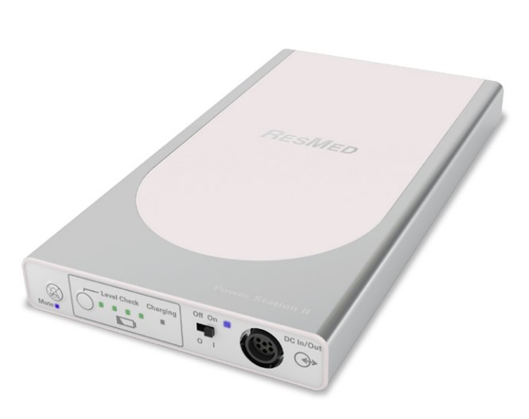
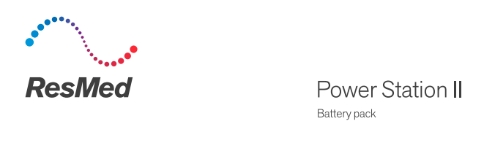

COMPONENTS

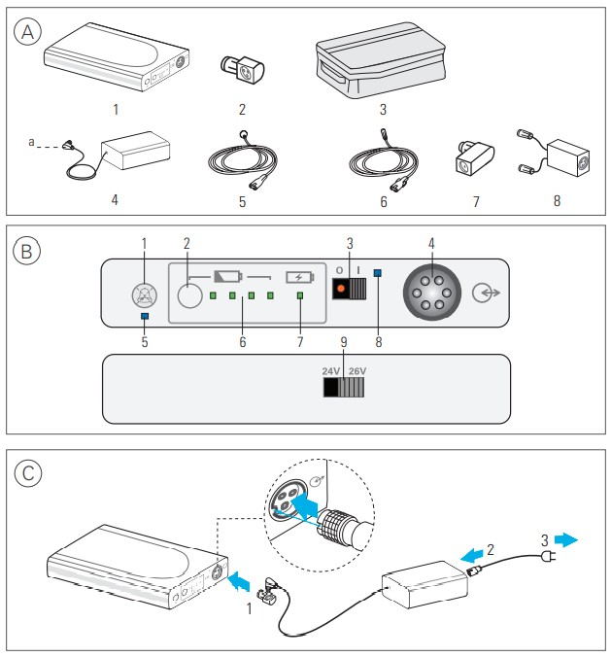
The ResMed Power Station II is an external lithium-ion battery that provides power when the main power is unavailable. The battery lasts approximately 8 hours if fully charged. It requires 4 hours to recharge after being depleted.

- Battery
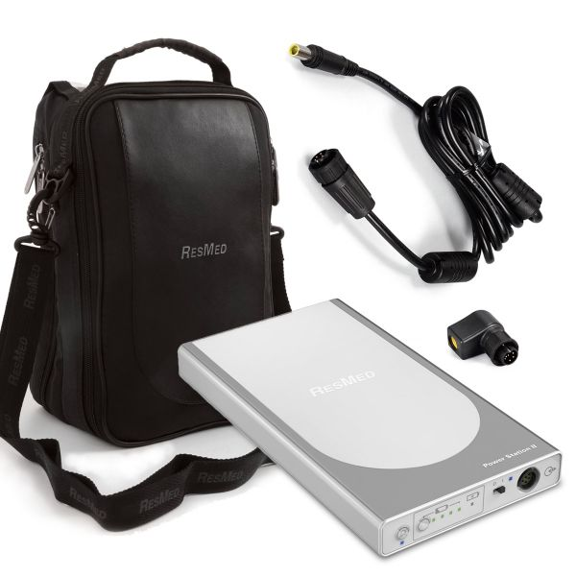
- Power Supply Adapter
- Carry Bag
- 90W AC power supply unit or DC converter
- AC or DC power cord
- DC output cable
- Air 10 Power Supply unit adaptor

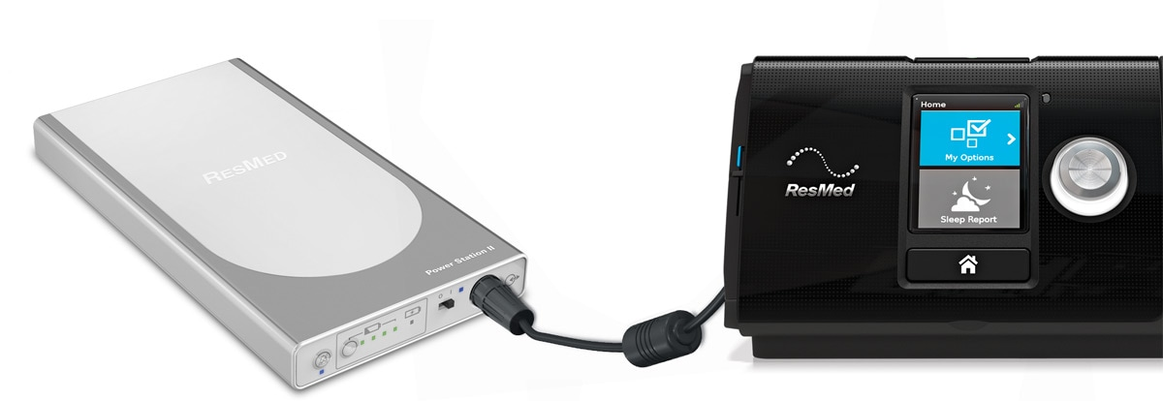

INDICATORS

- Audible alert mute button | - Charge level check button
- DC on/off switch | - DC input/output port
- Audible alert mute indicator | - Battery level indicators
- Charging indicator | - DC switch/discharging indicator
- Voltage output selector switch (rear panel)

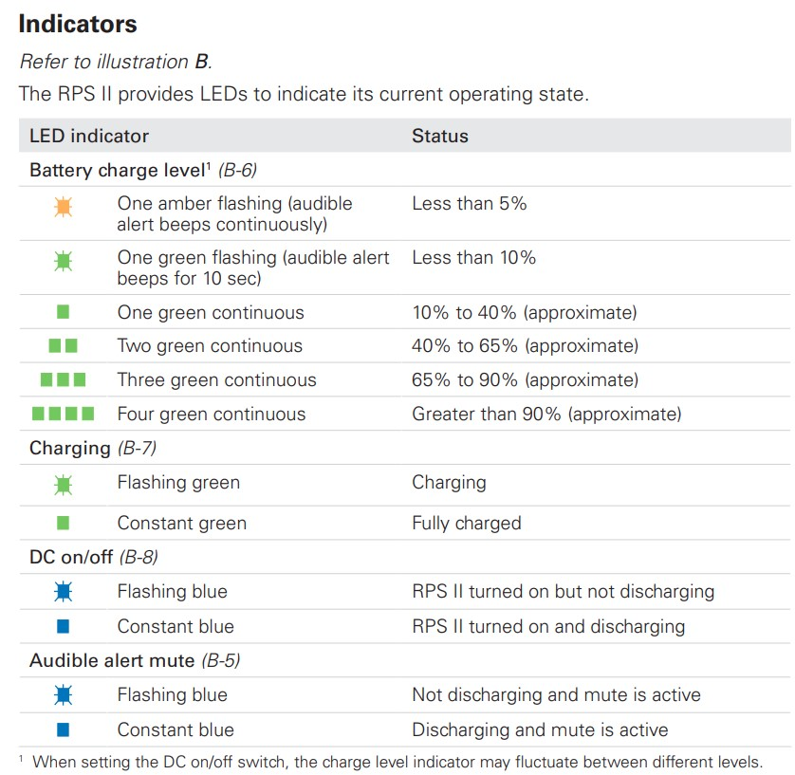

Charging the Battery
